


Math of Finance Syllabus
Course #: 10804144
Section: 62342
Credits: 3

Welcome
Welcome to the course—looking forward to working with you as we explore how mathematical ideas apply to financial decisions in everyday life and in business. The skills you develop in this Math of Finance class will support you in making informed choices about saving, borrowing, investing, and budgeting in the future.

Hello!
My name is M. Jeff Quinlan, and my pronouns are he, him & his. I prefer you call me Jeff (middle name) or Mr. Quinlan. I will post announcements each week in Brightspace for you to plan your week.

How do I contact my instructor?
Instructor Name: M. Jeff Quinlan
Email: mquinlan@madisoncollege.edu
Online Availability: By appointment
Phone: 608-246-6444

What will I learn in this course?
This course takes an algebraic approach to solving financial problems. Topics include personal finance, mathematics of retailing, mathematics of banking, and statistical applications. Major emphasis is placed on solving problems involving the time value of money by using a financial calculator. The material in this course develops a sound base for subsequent courses by using an analytical approach to problem solving.

How can I be successful in this course?
Regular practice is the key to success. The more often you engage with course activities, the more comfortable and confident you’ll become.

How will this course be structured?
Text material covered in the book will be covered in Connect but is ultimately the responsibility of the learner. It is expected that each chapter be read prior to attempting the assignments. A minimum 70% grade on each chapter’s problems is expected. A quiz should be taken soon after the learner has achieved a desired score on the topics covered in the homework. A minimum of 70% grade on each quiz and exam is also expected before moving to the next chapter. PowerPoint slides and real-world examples may be used to supplement text.

What textbook/materials/supplies are required for this course?
Math for Business and Finance: An Algebraic Approach, Slater, Jeffrey; Wittry, Sharon 3e
New York: McGraw-Hill Irwin. 2024. An All-Inclusive Access is included with your course fees. This includes an eBook and online access to Connect.
You will register the first time, when accessing through Brightspace.

Texas Instruments BAII Plus calculator is recommended as it will be required in future business classes.

What technology will I need to use in this class?
Having regular access to a computer will make it much easier to navigate and complete the online activities for the course.
We will use a Brightspace course site for this class. You can access it through Click here for the Brightspace Homepage. For student support information regarding Brightspace, visit the student technical support page.
Madison College does its best to keep Brightspace up and running. If you cannot access the course, contact the student help desk.

Where can I get access to a computer and/or wifi hot spot?
You can borrow laptop computers and wi-fi hot spots for the semester, at no cost as long as you are enrolled in a class. Microsoft and antivirus software will be pre-loaded to all laptops. Complete your equipment loan request online. You can call the student help desk at 608-243-4444 if you have any questions or need technology assistance. Students should bring their personal or college-loaned laptops to campus (with exceptions specific to courses and programs that have other requirements). This will ensure students can access academic resources as well as perform in-class work.

What important course policies do I need to know for this course?

My Commitment to You

As your instructor, I commit to communicating openly and frequently with you about this class. I will maintain a professional, safe learning environment adhering to the policies of the college. You can expect a reply to inquiries within 24-48 business hours.

My Expectations of You

Students are expected to be familiar with Madison College policies and procedures, along with monitoring you Madison College student email account.

Course Feedback
As we approach the end of the semester, a course survey will be available in Brightspace — I’d love to hear your feedback!

Attendance Expectations
Staying consistently engaged with course activities is important for success. Assignments that aren’t completed by the due date will be automatically submitted. Please try to avoid long gaps without participation, as this could lead to being marked as a No-Show and removed from the course.

Homework and Preparation Expectations
Because students come into this course with different levels of experience, the time needed outside of class will vary. However, a reasonable expectation is that most students will spend about 6–9 hours per week on coursework for this class, including reading, homework, and preparation for exams. Each week will look a little different, so it is important to read the weekly announcements for specific guidance.

Students with Disabilities (ADA Statement) and Title IX Pregnancy and Parenting Requirements
Madison College is committed to empowering students with disabilities, ensuring equal access to all academic programs and activities. To receive reasonable accommodations for your disability, you must contact Disability Resource Services (DRS). If approved, DRS will provide you with an accommodation plan. You can submit a request for services at the DRS webpage. You can contact the office anytime at 608-246-6716 or via email at drstransition@madisoncollege.edu. If you have an accommodation plan, please share it with me as soon as possible. If you believe your accommodations are not being met, please let me or DRS know as soon as possible.
According to Title IX of the Education Amendments of 1972, students must be allowed to take time off school for pregnancy, childbirth, miscarriage, abortion, and recovery for as long as their doctor says is medically necessary. Students with pregnancy-related conditions should submit the Student Pregnancy Accommodation Request form to make a request for modifications.
Artificial Intelligence (AI) Policy
Students may use AI tools (such as chat-based or generative programs) to support their understanding of course concepts, brainstorm ideas, or get help thinking through homework problems, as long as the work submitted is ultimately in their own words and they understand the material they turn in.
AI may not be used in any way on online quizzes, exams, or other assessments that are designated as individual work without assistance. Using AI on these assessments will be treated as academic misconduct and may result in penalties under the college’s academic integrity policy.
If AI tools are used to assist with homework or practice, students are expected to review the output critically, verify its accuracy, and be prepared to explain their work and reasoning.
The instructor may ask students to submit drafts, notes, or explanations of their process to confirm understanding and appropriate use of AI.

Late Assignment and Make-up Policies
Assignments are expected to be submitted by the posted due date and time. Late submissions are generally not accepted without prior communication and approval.
Extensions must be requested before the due date whenever possible. Requests made after the deadline may not be granted except in documented, extenuating circumstances.
Submission of Assignments
All coursework for this class will be completed and submitted online through the Connect homework management system. After you submit an assignment in Connect, feedback and scores will be available within the platform so you can review your work and identify areas to improve.

Syllabus Changes
I may modify the syllabus or schedule with reasonable notice to you. Look for an announcement in Brightspace.

How will my performance be assessed in this course?
A student’s grade will be determined entirely by the total points earned on Videos, LearnSmart activities, homework, quizzes and exams.
Component | Percentage Value
Connect LearnSmart | 6.0%
Connect Homework | 25.0%
Homework Packets | 10.5%
Connect Exams | 38.5%
Final Exam | 20.0%
Total: | 100.0%

Grading Calculations

Grading Scale: There is a total of 1,000 points to earn in this class.
Letter Grade | % Attained
A | 93-100
AB | 87-92.99
B | 80-86.99
BC | 76-79.99
C | 70-75.99
D | 60-69.99
F | 59.99-below

LearnSmart: Each chapter will have a LearnSmart activity to complete in Connect. LearnSmart is an adaptive learning tool that utilizes both reading and comprehension questions interactively to adjust to the needs of each student.
Homework: There are assignments to assist in comprehension of each chapter. These assignments are done online via Connect. Students are allowed multiple attempts on their homework and their highest score will be utilized for grade computation. Additionally, all homework will have a deadline beyond which they will not be accepted that is clearly designated in Connect.
Exams: There are exams to assist in comprehension of each chapter to be performed once you have mastered class concepts. These exams are done online via Connect. Students are allowed multiple attempts on exams and their highest score will be utilized for grade computation. Additionally, all exams will have a deadline beyond which they will not be accepted that is clearly designated in Connect.
Homework Packets: Students will fully completed by hand and emailed to the instructor. The Packets will have deadlines beyond which they will not be accepted.

Where can I find other college policies and resources that I should be aware of?
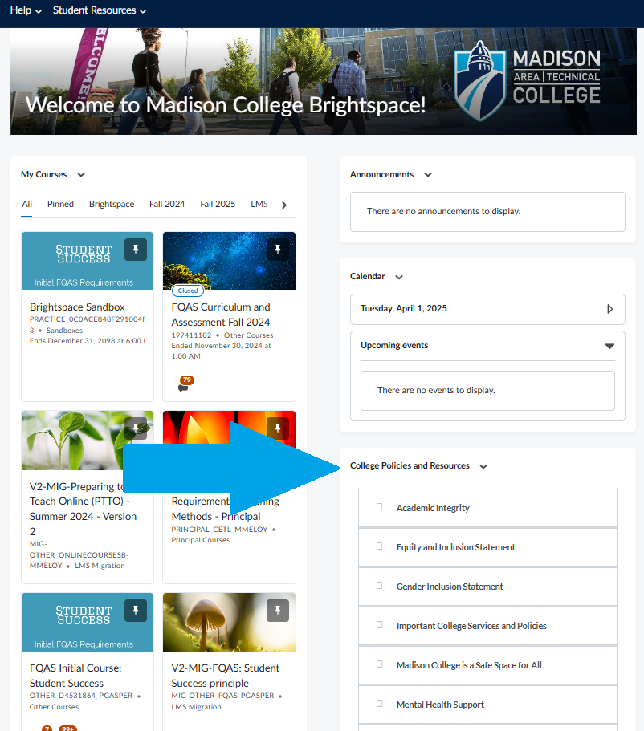
You can easily access important college policies and resources on the Brightspace Home Page in the "College Policies and Resources" section on the right side of the page. This section includes essential information like the Academic Integrity and Equity and Inclusion Statements, Gender Inclusion Statement, Mental Health Support, Laptop and Hot Spot Loaner Program, Students with Disabilities (ADA Statement), Title IX Pregnancy and Parenting Requirements, and information about campus closure due to weather or emergencies. These resources are available to help support your success throughout the semester.

